**Human Resources Migration Workflow System**

Human Resources Machine

**Section 4.** **Logical Database Design**

**Section 4.1 Entity Relationship Diagram (using Dia)**

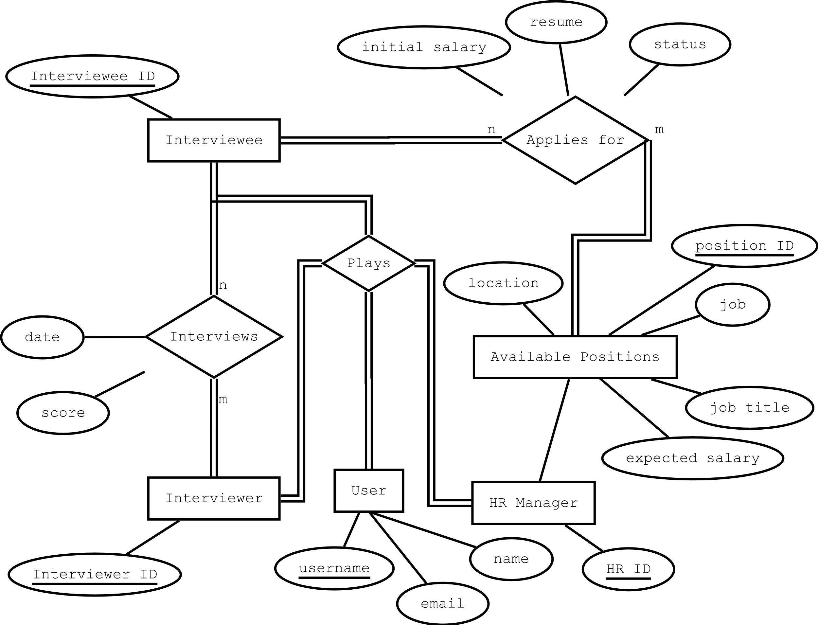

**Section 4.2 Logical Database Design (using MySQL Workbench)**

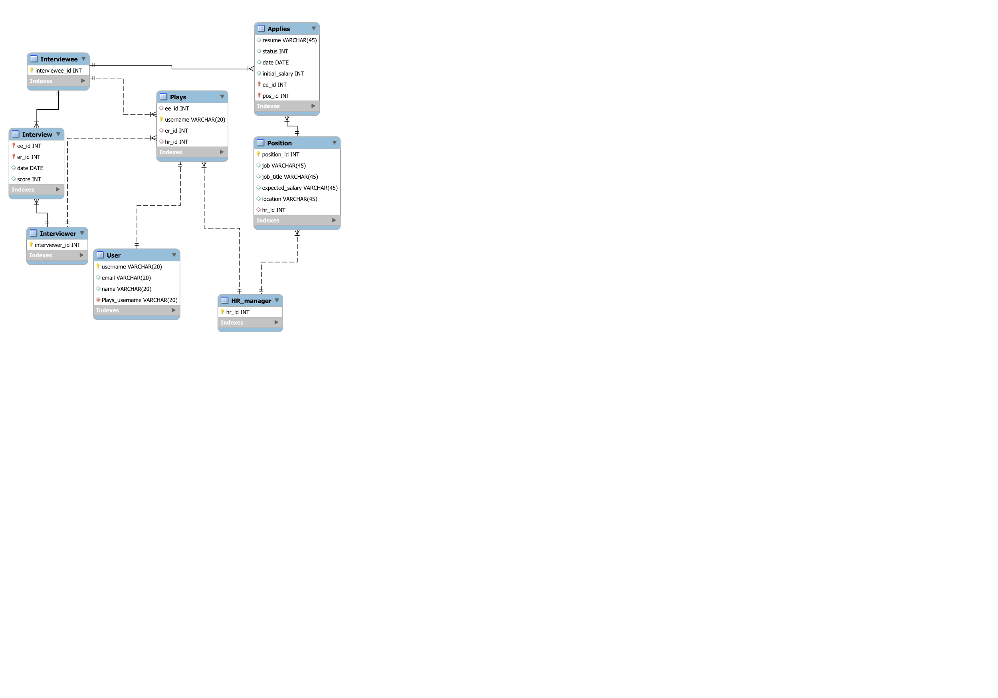

**Section 4.3 Database Schema (A system generated list of tables with attributes and constraints)**

-- MySQL Script generated by MySQL Workbench

-- Sun May 13 11:29:26 2018

-- Model: New Model Version: 1.0

-- MySQL Workbench Forward Engineering

SET @OLD_UNIQUE_CHECKS=@@UNIQUE_CHECKS, UNIQUE_CHECKS=0;

SET @OLD_FOREIGN_KEY_CHECKS=@@FOREIGN_KEY_CHECKS, FOREIGN_KEY_CHECKS=0;

SET @OLD_SQL_MODE=@@SQL_MODE, SQL_MODE='TRADITIONAL,ALLOW_INVALID_DATES';

-- -----------------------------------------------------

-- Schema HR_Migration_System

-- -----------------------------------------------------

-- -----------------------------------------------------

-- Schema HR_Migration_System

-- -----------------------------------------------------

CREATE SCHEMA IF NOT EXISTS `HR_Migration_System` DEFAULT CHARACTER SET utf8 ;

USE `HR_Migration_System` ;

-- -----------------------------------------------------

-- Table `HR_Migration_System`.`Interviewee`

-- -----------------------------------------------------

DROP TABLE IF EXISTS `HR_Migration_System`.`Interviewee` ;

CREATE TABLE IF NOT EXISTS `HR_Migration_System`.`Interviewee` (

`interviewee_id` INT NOT NULL AUTO_INCREMENT,

PRIMARY KEY (`interviewee_id`),

UNIQUE INDEX `interviewee_id_UNIQUE` (`interviewee_id` ASC))

ENGINE = InnoDB;

-- -----------------------------------------------------

-- Table `HR_Migration_System`.`Interviewer`

-- -----------------------------------------------------

DROP TABLE IF EXISTS `HR_Migration_System`.`Interviewer` ;

CREATE TABLE IF NOT EXISTS `HR_Migration_System`.`Interviewer` (

`interviewer_id` INT NOT NULL AUTO_INCREMENT,

PRIMARY KEY (`interviewer_id`),

UNIQUE INDEX `interviewer_id_UNIQUE` (`interviewer_id` ASC))

ENGINE = InnoDB;

-- -----------------------------------------------------

-- Table `HR_Migration_System`.`HR_manager`

-- -----------------------------------------------------

DROP TABLE IF EXISTS `HR_Migration_System`.`HR_manager` ;

CREATE TABLE IF NOT EXISTS `HR_Migration_System`.`HR_manager` (

`hr_id` INT NOT NULL AUTO_INCREMENT,

PRIMARY KEY (`hr_id`),

UNIQUE INDEX `hr_id_UNIQUE` (`hr_id` ASC))

ENGINE = InnoDB;

-- -----------------------------------------------------

-- Table `HR_Migration_System`.`Position`

-- -----------------------------------------------------

DROP TABLE IF EXISTS `HR_Migration_System`.`Position` ;

CREATE TABLE IF NOT EXISTS `HR_Migration_System`.`Position` (

`position_id` INT NOT NULL,

`job` VARCHAR(45) NULL,

`job_title` VARCHAR(45) NULL,

`expected_salary` VARCHAR(45) NULL,

`location` VARCHAR(45) NULL,

`hr_id` INT NULL,

PRIMARY KEY (`position_id`),

UNIQUE INDEX `position_id_UNIQUE` (`position_id` ASC),

INDEX `hr_id_idx` (`hr_id` ASC),

CONSTRAINT `hr_id`

FOREIGN KEY (`hr_id`)

REFERENCES `HR_Migration_System`.`HR_manager` (`hr_id`)

ON DELETE NO ACTION

ON UPDATE NO ACTION)

ENGINE = InnoDB;

-- -----------------------------------------------------

-- Table `HR_Migration_System`.`Plays`

-- -----------------------------------------------------

DROP TABLE IF EXISTS `HR_Migration_System`.`Plays` ;

CREATE TABLE IF NOT EXISTS `HR_Migration_System`.`Plays` (

`ee_id` INT NULL,

`username` VARCHAR(20) NOT NULL,

`er_id` INT NULL,

`hr_id` INT NULL,

PRIMARY KEY (`username`),

UNIQUE INDEX `username_UNIQUE` (`username` ASC),

INDEX `ee_id_idx` (`ee_id` ASC),

INDEX `er_id_idx` (`er_id` ASC),

INDEX `hr_id_idx` (`hr_id` ASC),

CONSTRAINT `ee_id`

FOREIGN KEY (`ee_id`)

REFERENCES `HR_Migration_System`.`Interviewee` (`interviewee_id`)

ON DELETE NO ACTION

ON UPDATE NO ACTION,

CONSTRAINT `er_id`

FOREIGN KEY (`er_id`)

REFERENCES `HR_Migration_System`.`Interviewer` (`interviewer_id`)

ON DELETE NO ACTION

ON UPDATE NO ACTION,

CONSTRAINT `hr_id`

FOREIGN KEY (`hr_id`)

REFERENCES `HR_Migration_System`.`HR_manager` (`hr_id`)

ON DELETE NO ACTION

ON UPDATE NO ACTION)

ENGINE = InnoDB;

-- -----------------------------------------------------

-- Table `HR_Migration_System`.`User`

-- -----------------------------------------------------

DROP TABLE IF EXISTS `HR_Migration_System`.`User` ;

CREATE TABLE IF NOT EXISTS `HR_Migration_System`.`User` (

`username` VARCHAR(20) NOT NULL,

`email` VARCHAR(20) NULL,

`name` VARCHAR(20) NULL,

`Plays_username` VARCHAR(20) NOT NULL,

PRIMARY KEY (`username`),

UNIQUE INDEX `username_UNIQUE` (`username` ASC),

INDEX `fk_User_Plays_idx` (`Plays_username` ASC),

CONSTRAINT `fk_User_Plays`

FOREIGN KEY (`Plays_username`)

REFERENCES `HR_Migration_System`.`Plays` (`username`)

ON DELETE NO ACTION

ON UPDATE NO ACTION)

ENGINE = InnoDB;

-- -----------------------------------------------------

-- Table `HR_Migration_System`.`Applies`

-- -----------------------------------------------------

DROP TABLE IF EXISTS `HR_Migration_System`.`Applies` ;

CREATE TABLE IF NOT EXISTS `HR_Migration_System`.`Applies` (

`resume` VARCHAR(45) NULL,

`status` INT NULL,

`date` DATE NULL,

`initial_salary` INT NULL,

`ee_id` INT NOT NULL,

`pos_id` INT NOT NULL,

PRIMARY KEY (`ee_id`, `pos_id`),

INDEX `pos_id_idx` (`pos_id` ASC),

CONSTRAINT `ee_id`

FOREIGN KEY (`ee_id`)

REFERENCES `HR_Migration_System`.`Interviewee` (`interviewee_id`)

ON DELETE NO ACTION

ON UPDATE NO ACTION,

CONSTRAINT `pos_id`

FOREIGN KEY (`pos_id`)

REFERENCES `HR_Migration_System`.`Position` (`position_id`)

ON DELETE NO ACTION

ON UPDATE NO ACTION)

ENGINE = InnoDB;

-- -----------------------------------------------------

-- Table `HR_Migration_System`.`Interview`

-- -----------------------------------------------------

DROP TABLE IF EXISTS `HR_Migration_System`.`Interview` ;

CREATE TABLE IF NOT EXISTS `HR_Migration_System`.`Interview` (

`ee_id` INT NOT NULL,

`er_id` INT NOT NULL,

`date` DATE NULL,

`score` INT NULL,

PRIMARY KEY (`ee_id`, `er_id`),

INDEX `er_id_idx` (`er_id` ASC),

CONSTRAINT `ee_id`

FOREIGN KEY (`ee_id`)

REFERENCES `HR_Migration_System`.`Interviewee` (`interviewee_id`)

ON DELETE NO ACTION

ON UPDATE NO ACTION,

CONSTRAINT `er_id`

FOREIGN KEY (`er_id`)

REFERENCES `HR_Migration_System`.`Interviewer` (`interviewer_id`)

ON DELETE NO ACTION

ON UPDATE NO ACTION)

ENGINE = InnoDB;

SET SQL_MODE=@OLD_SQL_MODE;

SET FOREIGN_KEY_CHECKS=@OLD_FOREIGN_KEY_CHECKS;

SET UNIQUE_CHECKS=@OLD_UNIQUE_CHECKS;

**Section 4.4 Your Meeting Log**

|  |  |  |  |  |  |
| --- | --- | --- | --- | --- | --- |
| ***No*** | ***Date and time*** | ***Duration*** | ***Location*** | ***Discussion topic*** | ***Attenders*** |
| 1 | 3/17/2018:3:00pm | 2.5 hrs | 709 Gewu | Project selection | Ning Zhang  Yingkai Sun  Yue Han  Yukun Ma |
| 2 | 3/23/2018:3:00pm | 2 hrs | 709 Gewu | Requirements | Ning Zhang  Yingkai Sun  Yue Han  Yukun Ma |
| 3 | 3/25/2018:8:00pm | 2 hrs | 709 Gewu | Requirements | Ning Zhang  Yingkai Sun  Yue Han  Yukun Ma |
| 4 | 4/1/2018:4:00pm | 2 hrs | 709 Gewu | Requirements | Ning Zhang  Yingkai Sun  Yue Han  Yukun Ma |
| 5 | 4/8/2018:19:00pm | 2 hrs | 709 Gewu | Use Case Diagram | Ning Zhang  Yingkai Sun  Yue Han  Yukun Ma |
| 6 | 4/14/2018:21:00pm | 1 hr | 709 Gewu | Use Case Diagram | Ning Zhang  Yingkai Sun  Yue Han  Yukun Ma |